***Exercise***

**ROLLBACK AND COMMIT**

Create a table named "T", having two columns:

id (of type integer, the primary key),

s (of type character string with a length varying from 1 to 40 characters)

* Insert 5 rows to the newly created table
* Select * from T;
* Observe the data in Table.
* ROLLBACK
* Select * from T;
* Observe the data in Table.
* SET AUTOCOMMIT ON;
* Insert 5 rows again in table.

**Transaction Isolation:**

**STEP 1:** Create a table TAB with an attribute tno.

**STEP 2:** Create a table t_log with attribute t_count.

**STEP 3:** Implement a PL/SQL procedure p1 that writes into a table t the numbers 1 to 100 (each in a separate tuple).

**STEP 4:** Write a procedure p2 that counts 5 times the number of tuples in it.

**STEP 5:** Inserts each of the counting results into a tuple in a log table.

**STEP 6:** Set isolation transaction mode to read committed with the following command. Set transaction isolation level read committed

**STEP 7:** Execute p1 and p2 concurrently on two pc’s separately, where both transactions are in read committed isolation. STEP 8: Check the content of the log table. How do you justify the obtained result?

**Transaction(Scenario):**

CEO has appointed two new employees ‘Qadir’ and ‘Asim’. They were asked to report to accounts department for inserting their records in employee table on Tuesday. Huda and Aman are dealing with employees in accounts department at two counters. Huda has to enter the data of Qadir at counter number 1 and Aman has to enter the data of Asim at counter number 2. ‘Huda the cashier’ has order to decrease the salary by 1000 rupees of employee #130 for not completing work on time. In the meantime employee number 130 apologizes and completes the work assigned to him. Boss calls the accounts department and the other cashier Aman picks the phone in office to increase the salary of employee #130 to 2000. Given are the transaction entries at the 2 counters:

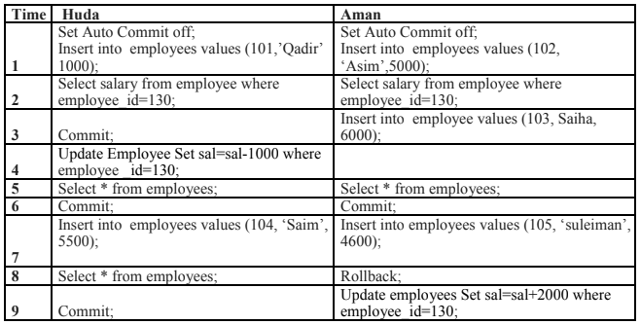

1. **Huda** Creates table employees(employee_id , name , sal) which is initially empty, the transactions run at isolation level Serializable, and the commands are issued in the order indicated above. What is the content of employees for Huda and Aman after each transaction?
2. If Aman cannot see the contents of employees table assign privileges to Aman for selecting, inserting and updating employees table.
3. Suppose that employee table is initially empty, the transactions run at isolation level Read committed, and the commands are issued in the order indicated above. What is the content of employees for User A and User B after each transaction? Take snapshot and show contents.
4. Suppose that employee table is initially empty, the transactions run at isolation level READ UNCOMMITTED, and the commands are issued in the order indicated above. What is the content of employees for User A and User B after the time 9? Is it possible?